Station 1 Photo:

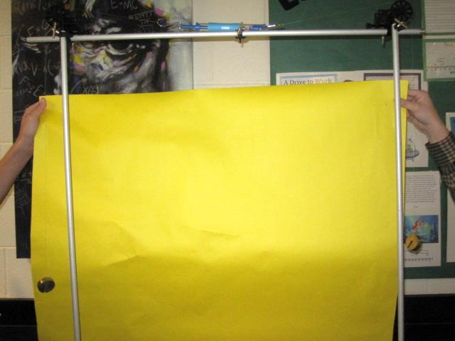

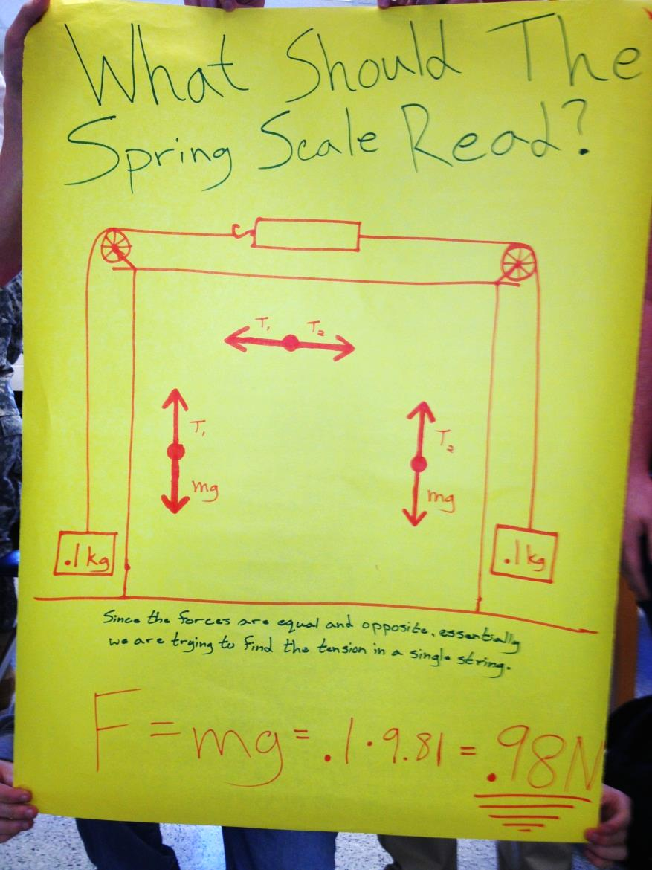Poster:

Station 2 Photo:

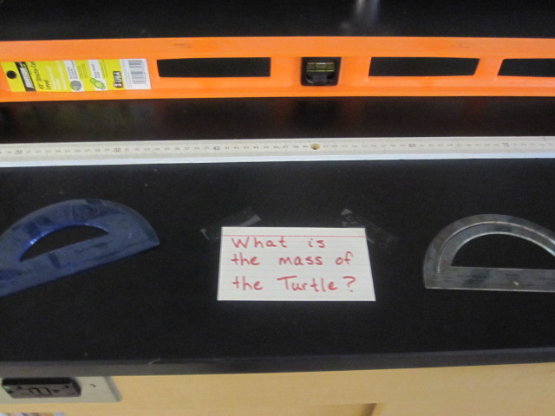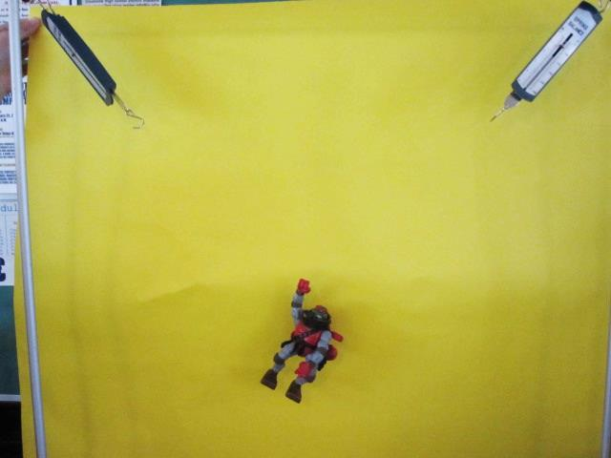  
Interesting: Since the turtle was centered, the tensions are equal to each other.

Poster:

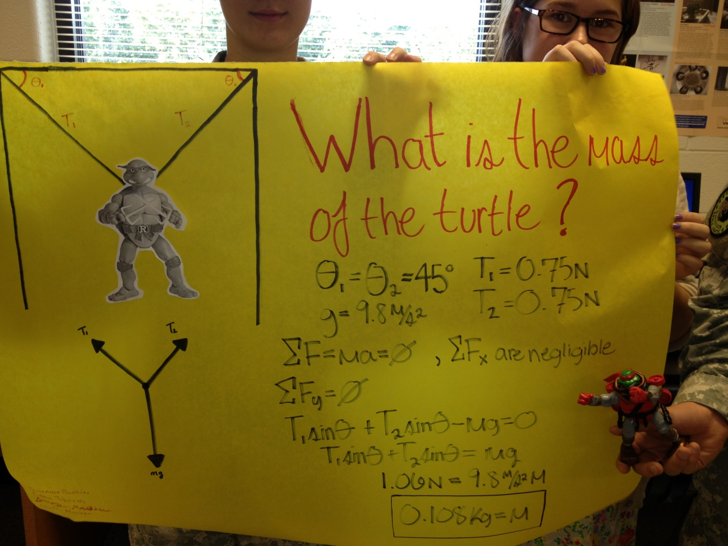

Station 3 Photo:

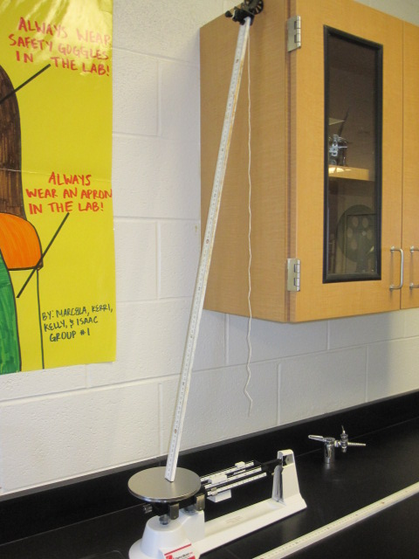

Interesting: Mu was = to COT of theta

Poster:

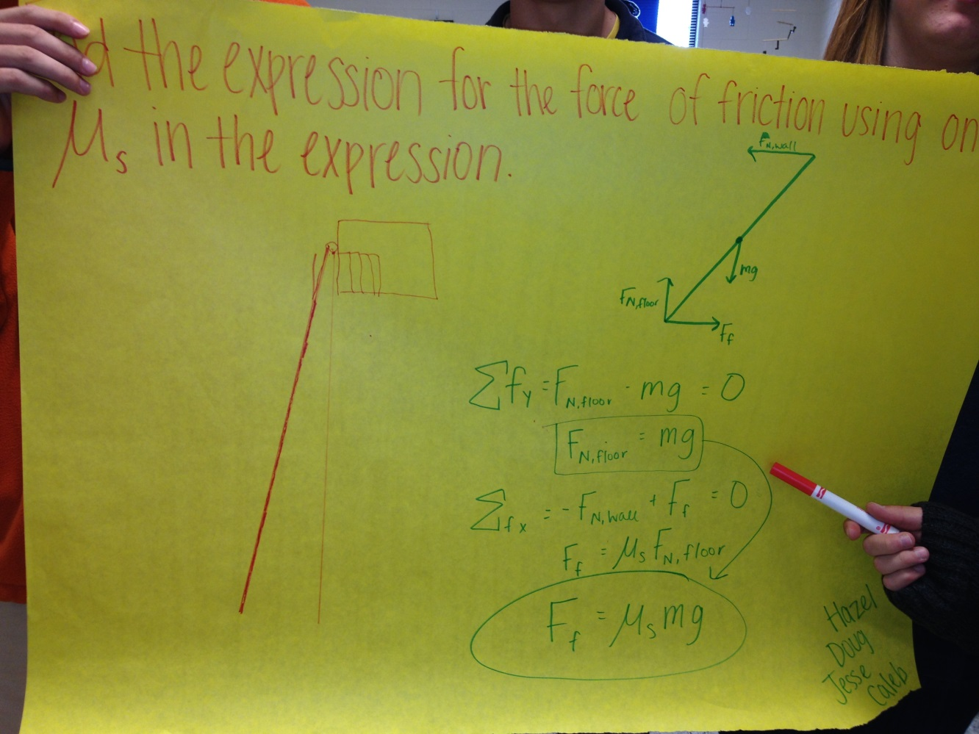  
Station 4 Photo:

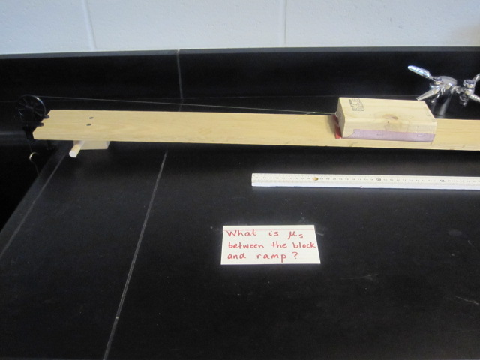

Interesting: The sandpaper on the block caused an increase in the friction coefficient.

Poster:

