- Purpose: To become familiar with the proper use a meter stick, a Vernier caliper, and a
micrometer to record measurements and estimate their uncertainty.

- Equipment: A meter stick, a Vernier Caliper, wood block, a cylinder, and a Micrometer.

- Procedure: 1) Determine the measurements of a block of wood using the Vernier caliper.
2) Utilize the measurements to calculate the volume of the wood block.
3) Determine the measurements of a cylinder using the Vernier caliper.
4) Utilize the measurements to calculate the volume of the cylinder.
5) Using the meter stick, find the measurements of the classroom.
6) Take the measurements, and find the area of the classroom.

Variables in this experiment mostly consists of human error during the taking of
the manual measurements. There are no independent variables in this
experiment.

- Data / Data Analysis:
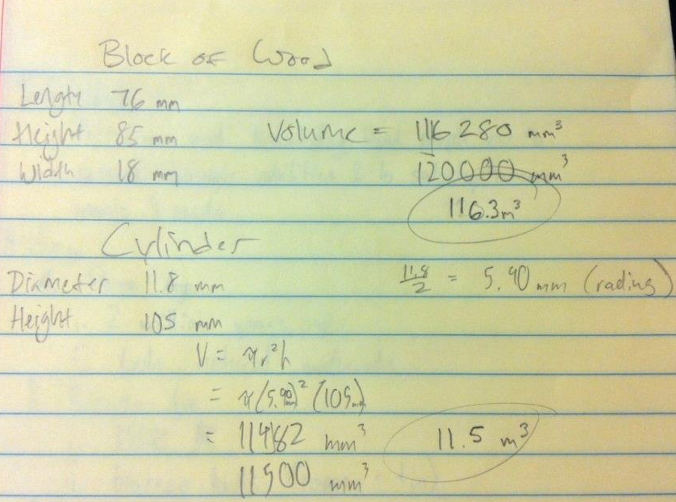
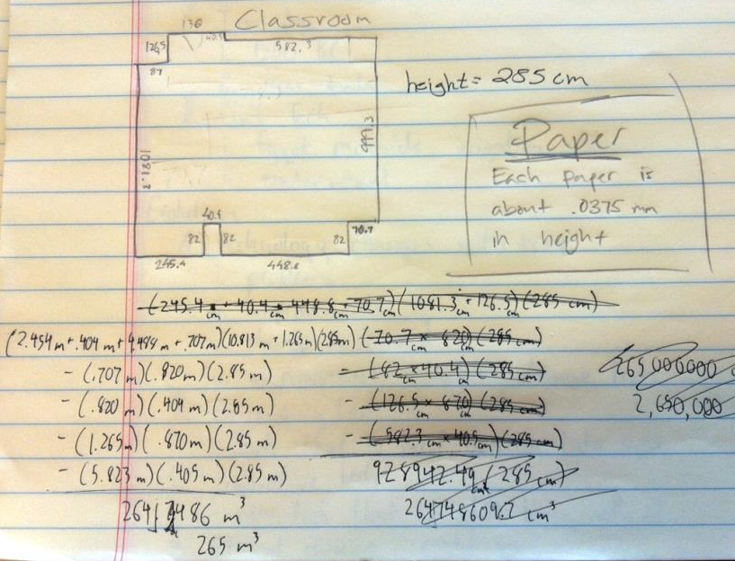

- Conclusion: During this lab, we expanded our knowledge of the proper use of a meter stick, a
Vernier caliper, and a micrometer. Throughout the process, the data remained
consistent and no surprising results were found. One of, if not the only, possible
source of error would have been mistakes with the measurements using the
meter stick as measuring around parts of the room were difficult.

